**Problem Statement**

**Problem**

The fear of Tasks (bills) being missed and forgotten resulting in financial or other penalties.

**Background**

Due to lack of notification, reminders, and time management, people are unable to complete some tasks or pay bills on time normally daily tasks but can be from monthly to quarterly, sometimes tasks are forgotten, this could be due to working on multiple smaller tasks or simply forgetting the importance of the task.

**Relevance**

Tasks are required day by day and is essential for working efficiently and effectively. If tasks are not completed on time this can cause penalties for the user, for example, if you forget a bill, you will incur a fee added on top of your bill

**Objectives**

We are going to be building a 3-tier native application using python3, that will assist in tracking tasks from bills to work related tasks. The application will consist of a simple dashboard that will allow users to track their tasks, add and modify their tasks. The application will use the calendar to also create events/ reminders if the user request

**Story Board**

**Dashboard / Index**



Task 1

Create New

Tasks

Task 2

Task 3

Task Dashboard

**Register**

Register

Cancel

Create Account

Create Password

Email

Last Name

First Name

**Login**

Login

Register

Login

Password

Email

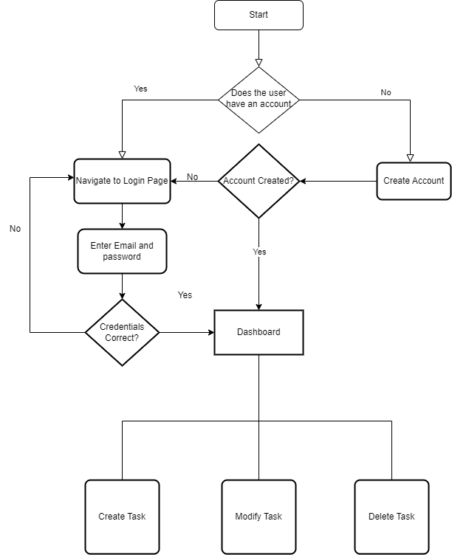

Architecture diagram

Front end

Functionality

Calendar API = https://developers.google.com/calendar/api/quickstart/python

Page load